# [**SVU Broke 2 Cardinal Rules With 24x12 Episode (Not to Mention Our Hearts)**](https://startefacts.com/news/rupert-grint-would-return-to-harry-potter-on-one-condition_a115)

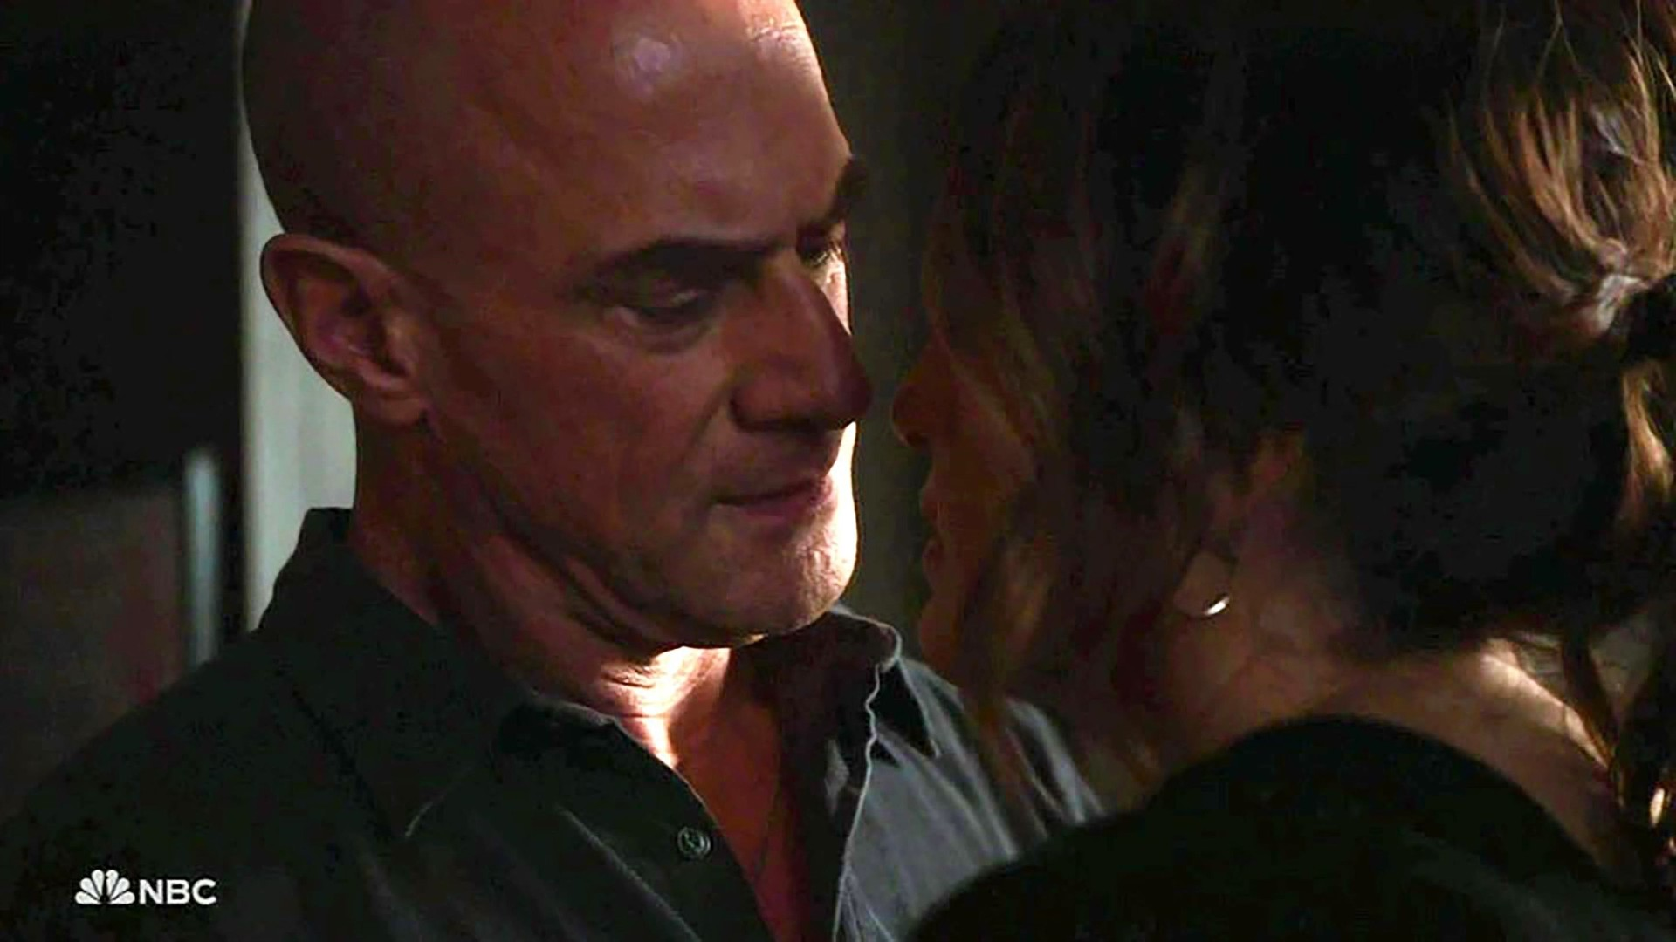Image credit: Legion-Media

The promo completely ruined Benson and Stabler's almost-kiss scene.

The promo for the [SVU](https://startefacts.com/tags/law--order-svu) episode Blood Out made the hearts of many longtime fans beat faster. In one short scene, it promised that after 24 seasons on SVU, Olivia Benson and Elliot Stabler might have finally reached the breaking point. It promised a kiss.

The episode was so hyped that even those who had been away for many years decided to tune in for it. After all, it was supposed to be the iconic moment of the iconic pairing. But to the dismay of millions of fans, all the build-up ended with almost nothing.

Well, NBC is sure to get high viewership numbers.

Fortunately, Benson and Stabler were not completely ignored in this episode. They almost kissed, which is already a victory for fans who have had no hope of a relationship for many years. But the moment was still disappointing. Why? There is a simple explanation. The promo makers broke two important rules: don't lie and don't give away anything in the last ten minutes of the episode.

[The One SVU Character Fans Are Happy Not to Be Dealing With Anymore](https://startefacts.com/news/the-one-svu-character-fans-are-happy-not-to-be-dealing-with-anymore_a122)

The most hyped part of the promo was from the literal last scene of the episode. What's worse, the romantic mood of the shot they used in the promo was very different from the tense atmosphere of the scene in the episode. The promo certainly spoiled most of the scene and ruined a genuine emotion that the viewers could have had.

*Without the crazy anticipation, the surprise of the moment unfolding naturally could have been an incredible experience for fans. They would have had a chance to enjoy Elliot and Olivia's conversation without having to wait for the kiss that didn't come.*

The brilliant acting of the stars would certainly allow viewers to do so. Even after 24 years, Benson and Stabler's palpable chemistry hasn't gone anywhere, and the two are slowly building their relationship after many years apart. Most fans agree that jumping into a kiss or sex scene would ruin the slow buildup that is going on. But at the same time, the show's failure to deliver on its promises felt a lot like a betrayal.

How will this almost kiss affect Olivia and Elliot's future relationship? Will Benson ever be ready to act on her feelings for Stabler? The only way to find out is to wait and see. Next episode airs tonight, February 2, 2023.